Classical Swarm B

A Swarm of Interacting Particles that don’t Interact:

Classical and Quantum Analytic solutions and examples

J. West and S. P. Bartz, Department of Chemistry and Physics, Indiana State University

Papers Now:

Classical introduction, big deal about arbitrary {Mi} and initial conditions. Include the bouncing behavior. Focus on closed elliptical orbits, makes tracking effects (Like Oberth vs Hohhman) easy. Focus on orbital periods are all identical. Focus on NO SCATTERING AT ALL. They just ignore each other.

Can also have damping linear in velocity. Fun for only on one, would be fun for ALL or maybe with only N/2 of them. They ALL stay separable in x,y,z, and independent….would they all just collapse to the center? NO, I think that my paper showed that you end up at the center of wind resistance (sub b*r/(sum b)). Also, dynamics will be a mess. Wind resistance means that CM will move around… maybe could separate that out in some for F = -BV = M(dV/dt) for center of mass?? Fun also as we could make all masses different, and make -bv be the same for all, or could also assign random values of b. Notice though we lose our analytic solutions….unless I can find something really clever, since with wind, the CM will start moving around.

Can we put Kepler together with this some how with a perturbation method? Bound Kepler orbits with a spring perturbation (the Kepler orbit is close, so x^2 never gets big).

It is assumed that the interactions are instantaneous (speed of light is infinite).

**Abstract**

A two-body point particle interaction force law of the form **F** = -Jm1m2**r** is introduced, where the force F, is directed along the line connecting the particles, m1 and m2 are the masses of the particles, r is the distance between them, and J is a constant. This force law permits exact 3D solutions of position as a function of time for any finite number of particles in a “swarm” N, with any distribution of mass choices, and any initial conditions. The motion of any individual particle is otherwise completely independent of the motion of the N-1 other particles, and is described by a closed ellipse centered on the system center of mass. The period T of all N particles is identical regardless of the individual masses, and depends only on J and the total mass. Consequently, the potential energy of each particle is determined uniquely in terms of its mass, the total mass, and the distance between the particle and the center of mass. With such simple mathematical form, this novel system is suitable for student exploration of orbital motion. Regarding quantum applications, this implies that the Hamiltonian is completely separable so that the quantum equivalent N-body wavefunction is a simple product of the appropriate 3D Simple Harmonic Oscillator states. This is already known for the case of N identical particles, but the results presented here imply that it is also true for an arbitrary choice of particle mass and spin values. An extension to Fermion and Boson wavefunctions is straightforward and explored in a subsequent paper.

**Introduction**

In considering the form that the universal law of gravitation between two point masses might take, the characteristics of the orbits of the planets, as summarized by Kepler’s Laws and Newton’s Third Law indicate specific mathematical properties that such a law must take. The orbits of the planets sweep out equal areas in equal time, indicating that angular momentum is conserved, so it must be a central force. Newton’s Third Law implies that the mass of each particle must appear as a simple product. That the orbits are closed ellipses, restricts the dependence on the distance between the masses r, to one of only two possible cases. The first is the familiar inverse square law

$F_{G}=-\frac{Gm_{1}m_{2}}{r^{2}}\hat{r}$ (1)

where F is the force on one of the particles, m1 and m2 are the masses of the two particles, r is the distance between them, and G is the well-known gravitational constant (G = 6.67 x 10-11 Nm2/kg2). The subscript “G” is used to distinguish this case. It is well-known that the interactions of spherically symmetric masses are of the same form, and that a mass within a hollow spherically symmetric shell feels no net gravitational force.

The second allowed case that leads to closed elliptical orbits is the topic of this paper, is linear in the distance r, resulting in a force in the form of an ideal isotropic ideal spring

$F_{J}=-Jm_{1}m_{2}\vec{r}$ (2)

where J is a new constant with units of N/(kg2m). (XX refs for this solution XX). The form that works for our universe, and meets Kepler’s T2-R3 law is that of Newton’s Law of Gravitation. As is well known, the linear form results in a period that is independent of the size of the orbit. While the discussion presented here will primarily be in the context of a universal gravity like force, it is important to note that the same expressions and conclusions also apply to a system of any masses attached pair-wise with springs where the masses are connected to each other pair-wise via springs with the spring constants chosen so that the constants are proportional to the product of the pair of masses

$F_{i,j}=-K_{i,j}{\vec{r}}_{i,j}$ (3a)

$K_{i,j}≡Jm_{i}m_{j}$ (3b)

where Ki,j = Jmimj, and J is still a constant with units of N/(kg2m). The term “J-Force” will be used to refer to the force law in either form Eq. (2) or Eq. (3). In the case that m1 >> m2, the motion of m2 will be a closed elliptical orbit about m1. If the masses are comparable in magnitude, they orbit about their common center of mass in closed elliptical orbits.

Many such masses N, forming a “swarm” could then be envisioned to be interacting with each other in an N-body solar system. It is for the cases of N > 2 that the interesting aspects of the swarm become most evident. When interacting via the J-Force, one can show that the motion of any particular mass mi within the swarm will be identical to that for the same mass attached to the swarm center of mass location by a **single** ideal spring with spring constant JMmi, with M equal to the total mass of the system (including mi). That particle will maintain smooth elliptical motion regardless of how near or far any of the other N – 1 masses in the swarm are at any given moment, or what their motion is, as long as the center of mass of the system is not accelerating due to external forces.

The term “scattering” would not, as a technical term, be applied to an interaction that does not permit the objects involved to separate to infinite distance. But in this case, the effect of having all of the other N-1 masses interact with a single mass mi such that mi moves through space as if it is completely unaffected by the N – 1 other masses. This result seems similar in some regard to the result of no net gravitational net force on a mass free to move within a massive spherically symmetric shell (XX refs XX) in the case of Newtonian gravity.

For the gravitational application, every mass in the J-swarm universe orbits in a closed elliptical path about the center of mass of the total mass of the universe. Every mass orbits about that center of mass with the same (universal) orbital period. Welding some of the masses together into various shapes will have no effect on their orbital properties at all. The center of mass of the welded object will also move in an ellipse about the center of mass of the universe! Neither orientation or rotational motion will affect the trajectory.

The independent nature of the motion of each mass has important implications for the equivalent quantum mechanical systems. In fact, it would appear that the system of N identical particles has been well-known in quantum mechanics for quite some time (XX a lot of our references XX). There was, however, only marginal recognition of the possibility of simple solutions on the classical side from those references (XX see in particular, ref. XXX that suggests a classical solution for N = 3 might have been found XX).

The results presented here, however, indicate that the separable form of the dynamics extends to include N masses with arbitrarily chosen mass values. As a general result, the Hamiltonian is completely separable by particle, and each particle separable into x, y, z dependence so that the N-body wavefunction of a swarm is a simple product of independent particle and coordinate SHO states (of the form Y = Pin(psin(x)*psin(y)*phsin(z)). Even with different masses, it can easily be shown that the energy level spacing of all of the particles is identical (because the classical period for each is identical). As more particles are added to the system, the energy level spacing increases, and as a result, it can also be shown that for a given temperature there is a finite limit to the number of particles that can be in the excited state. This is similar to the famous BEC condensation found for bosons at low temperatures, but due to an entirely different mechanism, as it does not rely on the particles being identical. The particles instead would follow Maxwell-Boltzmann statistics. (XXX ref to our quantum version XX).

The remainder of the manuscript is organized as follow: Section IIa presents the model the relevant derivations of the center of mass form of the force law, and the equivalent expression for the single particle potential energy; Section IIb then outlines the steps necessary to produce the desired wavefunctions of the system. Section IIIa presents some additional results of the classical system and IIIb some additional results of the quantum system. Conclusions are provided in Section IV. Supplemental materials include a number of short Python / Tinker code programs. These include one for plotting the orbits of an N-particle system given a specified set of mass and initial condition values based on the SHO expressions for r(t); a similar program that runs a numerical simulation of a similar system directly from the pair-wise forces.

**II. Linear Gravity (SHOG, J-Force interactions….??)**

Consider a short comparison of the behaviors of the force and potential energy expressions for the linear J-Force force law and for Newtonian gravity

$F_{J}=-Jm_{1}m_{2}\hat{r}$ $F_{G}=-\frac{Gm_{1}m_{2}}{r^{2}}\hat{r}$ (3)

$U_{J}(r)=(Jm_{1}m_{2}r^{2})/2$ $U_{G}(r)=-(Gm_{1}m_{2})/r$

$U_{J}(0)=0$ $U_{J}(∞)=∞$ $U_{G}(0)=-∞$ $U_{G}(∞)=0$

The dynamics of a single mass m attached to a single isotropic ideal spring, a topic that is commonly covered in undergraduate courses (XX ref to our mechanics books XX). This case would be the equivalent of choosing a very large mass ratio (M >> m), similar to what one normally does when first investigating the Newtonian force law. For the linear force law, the force can readily be broken into components. The expressions for x, y, and z are all equivalent, and so here the motion will be restricted to the x-y plane to reduce redundancy. The J-force is separable

$F_{Jx}=-JMmx=m\ddot{x}$ (4)

$F_{Jy}=-JMmy=m\ddot{y}$

and the resulting solution for the position is one of the most well-known in all of physics, that of simple harmonic motion given by

$x(t)=A_{x}cos\left(ωt\right)+B_{x}sin\left(ωt\right)$ (5)

$y(t)=A_{y}cos\left(ωt\right)+B_{y}sin\left(ωt\right)$

$ω={\left(JM\right)}^{1/2}=\frac{2π}{T}$

where the set of constants {Ax, Bx, Ay, By} are determined by the initial position and velocity of the particle. In all cases the resulting motion forms a closed ellipse with the center of the ellipse at the center of mass of the system. Due to the fact that J is proportional to m, the period T, is identical for each particle, as is the case for Newtonian gravity.

Will probably move this later as a tie-in for possible student projects.

For the special case of a particle attached to its paired spring, and moving in a circle, the speed of the particle VJc and its total energy EJc are found with standard relationships. Such information can be useful, if one would like to take a spaceship around the J-Force solar system.

$V_{Jc}=JMr^{2}$ $E_{Jc}=2KE = 2U = JMmr^{2}$ (6)

For comparison the equivalent expressions for a circle orbit in Newton’s Gravity is

$V_{Gc}=GM/r$ $E_{Gc}=-KE = -GMm/(2r)$ (7)

End Segment

These results are not restricted to the case of only two masses and M >> m. Consider the case of three fixed force centers of masses m << M1, M2, and M3, located at the coordinates (X1, Y1), (X2, Y2) and (X3, Y3) respectively, and m located at (x, y), as shown in Fig. XXX. The net force applied by this trio of large masses is nicely handled by breaking the forces into x-y components

$F_{Jx}=-JM_{1}m(x-X_{1})-JM_{2}m(x-X_{2})-JM_{3}m(x-X_{3})=m\ddot{x}$ (8)

$F_{Jx}=-JM_{1}m(y-Y_{1})-JM_{2}m(y-Y_{2})-JM_{3}m(y-Y_{3})=m\ddot{y}$

Expanding and collecting terms gives the equations of motion for m

$\ddot{x}=-J(M_{1}+M_{2} +M_{3})x+JM_{1}X_{1}+JM_{2}X_{2}+JM_{3}X_{3}$ (9)

$\ddot{y}=-J(M_{1}+M_{2} +M_{3})y+JM_{1}Y_{1}+JM_{2}Y_{2}+JM_{3}Y_{3}$

The solution is a minor variation of the expression in Eq. (5)

$x(t)=A_{x}cos\left(ωt\right)+B_{x}sin\left(ωt\right)+C_{x}$ (10)

$y(t)=A_{y}cos\left(ωt\right)+B_{y}sin\left(ωt\right)+C_{y}$

$ω={\left(JM\right)}^{1/2}$

$C_{x}=\frac{M_{1}X_{1}+M_{2}X_{2}+M_{3}X_{3}}{M_{1}+M_{2}+M_{3}}$ $C_{y}=\frac{M_{1}Y_{1}+M_{2}Y_{2}+M_{3}Y_{3}}{M_{1}+M_{2}+M_{3}}$

The motion is still a closed ellipse, but now it is centered on the coordinates (Cx , Cy) which are by definition, the coordinates of the center of mass of the fixed centers M1, M2 and M3. This is a remarkable result. Three arbitrary (but large) masses produce a motion that is consistent with that of a single large mass M equal to their total mass and located at the center of mass. It is important to note that the motion of m does not depend on the details of where the individual force centers are located, only on the location of the center of mass.

This result can in fact be generalized to any arbitrary distribution of the large attractive mass. Consider placing the point mass m at the origin. A large mass M (>> m) is distributed in space within a well-defined volume V, with a density ρ(**r**) depending on the location **r** within that volume (see Fig XX). In that case, the force on m due to a small volume element dV within the extended body is

$dF=-Jmρ\left(r\right)rdV$ (11)

The total force is found by integrating over the volume of the extended body

$F=\int{dF}=-Jm\int{ρ\left(r\right)rdV}≡-JmMR_{cm}$ (12)

Notice, due to the linear nature of the J-force law, there is no difficulty in allowing m to be located **within** the larger mass distribution. As noted before, the size and shape of the external mass have no effect on the form of F, beyond determining the location of the center of mass. The shape, size, and motion of the external body have no effect at all on the motion of m! The large mass does not need to be a rigid body, and it may rotate in any arbitrary manner, as long as it is rotating about its center of mass, which is how unconstrained bodies do rotate (XX big refs here XX). The J-force field of a massive system is then given as **j** = **F**/m = -JM**r** where M is the total mass of the system and **r** is measured from the center of mass of the system (similar to often-used convention for **g**(x,y,z) = **F**/m) = -(GM/r2)**r**.

As an example illustrating that the J-force is independent of the distribution of M, consider an example commonly used from Newtonian gravity (and electrostatics) that appears in many textbooks. A point mass (at the origin) is interacting with a thin uniform rod of length L, total mass M, with mass density h (h = M/L). The rod is oriented along the x axis and the ends are located at Xo and Xf (L = Xf – Xo, see Fig. XXX). As customary, the thin rod will be sliced up into tiny slivers of width dx, between Xo and Xf, each sliver of mass dM = hdx. (Conversely, one can consider attaching very tiny springs, each tiny spring having a force constant Jm(dM)). Each sliver produces a force on m given by

dFx = -J(dM)mx = -(Jhmx)dx (13)

This can be integrated to find the total force on m

$F_{x}=-Jmh\int_{Xo}^{Xf}{xdx}=-Jmh\left(\frac{X_{f}^{2}-X_{o}^{2}}{2}\right)=Jmh(X_{f}-X_{o})\left(\frac{X_{f}+X_{o}}{2}\right)=-JMmX_{cm}$ (14)

Consider now the motion of two masses m1 and m2, with position vectors **R**1 and **R**2 respectively, which are comparable in size and free to move relative to each other. Following a path similar to other derivations that introduce the reduced mass (XX Cassiday Chpt. 7) take the origin to be at the center of mass and look at the equation of motion for m1

m1**R**1 + m2**R**2 = 0 (15)

The motion of m1 is the same as it were orbiting fixed mass M equal to the **total mass of the system (M = m1 + m2)**. The expression for the potential energy of m1 can also be expressed directly in terms of the total mass and the distance from the center of mass. The work W1 needed to move m1 from the origin (where the force is zero) to its current location

$W_{1}=∆U_{1}≡\int_{0}^{R_{1}}{Fdr}=JMm_{1}\int_{0}^{R_{1}}{r∙dr}≡(JMm_{1}R_{1}^{2})/2$ (16)

Notice, if m1 moved, but the center of mass remained fixed at the origin, then the other mass must have also moved, and work done in pulling it away from m1 is of the same form so that

$W=W_{1}+W_{1}=∆U=(JM/2)(m_{1}R_{1}^{2}+m_{2}R_{2}^{2})$ (17)

The specific form that the potential energy U, takes has a significant impact on the mathematics of solving problems in quantum mechanics, and so it is important to generalize the results of Eq. (17) to the full N-body system containing N masses {mk} located at positions {**r**k}. Two approaches give consistent expressions. In the first, consider the rather brute force step of adding up the energy stored in all of the springs connecting each pair of particles, with the origin chose at the center of mass

$\sum_{k}{m_{k}r_{k}}=R_{cm}=0$ (18)

The potential energy of all of the stretched springs is then

$U=\frac{1}{2}\left[\sum_{j,k}{\frac{1}{2}Jm_{j}m_{k}{\left(r_{j}-r_{k}\right)}^{2}}\right]=\frac{J}{4}\left[\sum_{j,k}{m_{j}m_{k}\left(r_{j}-r_{k}\right)∙\left(r_{j}-r_{k}\right)}\right]$ (19)

The factor of ½ in front of the brackets accounts for the fact that the double sum will double count the springs. The case of j = k does not need to be separated out from the sum, as that term is always zero.

$U=\frac{J}{4}\left[\sum_{j,k}{m_{j}m_{k}\left(r_{j}^{2}+r_{k}^{2}-2r_{j}∙r_{k}\right)}\right]$ (20)

Now, separate out each term in the parenthesis

$U=\frac{J}{4}\left[\left(\sum_{j}{m_{j}}\right)\left(\sum_{k}{m_{k}r_{k}^{2}}\right)+\left(\sum_{k}{m_{k}}\right)\left(\sum_{j}{m_{j}r_{j}^{2}}\right)-2\left(\sum_{j}{m_{j}}r_{j}\right)∙\left(\sum_{k}{m_{k}}r_{k}\right)\right]$ (21)

The last term must be zero for **each** of the sums, as this is the expression for the location of the center of mass (see Eq. (18)). The summations over mass alone in the first two terms simply gives the total mass M, and both of those terms are identical. The resulting potential energy U is a sum of independent harmonic oscillator potentials.

$U≡\sum_{k}{U_{k}}=\sum_{k}{\frac{1}{2}{JMm}_{k}r_{k}^{2}}$ (22)

As an alternative approach, one can use the expression in Eq. (12) directly and calculate the work required to move the particles around. Specifically, consider letting all N particles begin at the origin {**r**k = 0}. Notice, overlapping particles do not cause any divergence in the potential energy for linear gravity. Overlapping particles have zero potential energy. From that initial configuration, all of the particles are moved to their final locations {**R**k}, but this motion must result in a set of final position such that the center of mass is still at the origin. So, the work done in moving any single mass Wk is given by

$W_{k}≡U_{k}=\int_{0}^{R_{k}}{JMm_{k}r_{k}∙dr_{k}}=\int_{0}^{R_{k}}{JMm_{k}r_{k}dr_{k}}$ (23)

Where the last equality follows from the fact that the J-force does work on the particle only for the radial portions of displacement. The integral for U is recognized and the total potential energy of the system is found to be the same as found in Eq. (22)

$U=\sum{W_{k}}=\sum_{k}{\frac{1}{2}{JMm}_{k}r_{k}^{2}}$ (24)

Each particle in this system, regardless of its mass, will orbit about the location of the center of mass of the **entire system**. This motion is independent of the motion of any/all of the other individual masses This is very surprising, given the rapid increase of the force with separation, and the interaction of any given mass with **all** of the other masses. This fact is known from the quantum applications/references (XX refs XXX) that the Hamiltonian is “separable” would seem to imply exactly this result, still it seems counter-intuitive.

NOTE: It might be useful for students to use two large fixed point masses and calculate the work done on moving a smaller point mass mi from the center of mass to some arbitrary location. With only two fixed masses the force on m can be written in component form without much difficulty and the integration can then be finished easily. The result can then be compared to the result obtained by summing over the three stretched springs. This is instructive as one ends up with an “extra” constant term from the spring summation method. That is due to the fact that one is staring with the two fixed masses already separated, and so at least that spring is already stretched.

**III. Applications and Examples**

**IIIa. Orbital Transfer**

The work presented in this paper grew out of an attempt at developing (JW) a new homework problem on orbital mechanics for a junior level mechanics class. The homework application was centered on using the fact that only central forces in the form of the inverse square law and Hooke’s law produce closed elliptical orbits. The case of the Hooke’s law interactions (M >> m) leads to the nice closed form analytic solutions for position and velocity as functions of time, making them even more amenable to calculations than the inverse square case. The dynamics of an orbital transfer problem (circular orbit to a new higher circular orbit) for the inverse square law are well-known and often presented in advanced undergraduate text books (XX give a couple of refs XX). For that case, once can obtain analytic results for orbital speeds for each circular orbit, and the speed of the orbiting object at perihelion and aphelion for the intermediate orbit. Knowing those speeds and an exhaust velocity, one can also determine what fraction of the ship must be in the form of fuel to be burned for each step in the maneuver.

As a long example (or really long homework problem/project) students can work through three cases of interest of particular interest for the same desired change in orbital radius. In the first case, the transfer is accomplished with two “burns,” the first is radial, and the second is tangential. The second option is to perform two tangential burns. This option is much more fuel efficient than the first, and is known as the Hohmann transfer. The third option is the Oberth maneuver, which is even more fuel efficient than the second option. This does require a total of 3 “burns.” It is especially interesting as the first burn provides thrust opposite to the direction of the orbit, and so causes the orbiting object to slow down! However, that results in an elliptical orbit with a lower closest approach, and a higher speed at closest approach, which makes the second “burn” that is oriented in line with the velocity much more energy efficient and results in an elliptical orbit with the furthest distance at the desired final orbital radius. A final third “burn” then completes the maneuver.

Now, for the new homework problem. Work out all three case for the Hooke’s law form of gravity. How do the efficiencies compare now? Is the Oberth maneuver still viable? Notice that for the case of the Hooke’s law form, students could also animate the orbits, given that the orbits of the orbital object are know as functions of time. At each “burn” one just has to adjust the Ax, Ay, Bx, and By coefficients to match the new velocity

It is now fun to ask students to consider what happens to the fuel that was burned and thrown out the back of the rocket. If the speed of the fuel relative to the fixed mass is less than escape velocity for the Newtonian case, then for both force laws the fuel will be put into a closed elliptical orbit. The fuel and the ship will be on orbital paths that must still pass through the point at which the burn occurred. In the Newtonian case, the orbital period of the ship and that of the fuel are almost guaranteed to mean that the fuel and the ship never meet up again.

For the Hooke’s law form, the fuel and the ship are guaranteed to meet up again, at that spot **every orbit!** All masses in the system orbit with the same period. The only way to avoid the fuel is to burn again at some other point in the new orbit….but then ship and fuel from latest burn are destined to meet again on every orbit. What an odd universe to live in! Students could animate the paths of the ship, and each packet of fuel, in a simulation, because all of the paths of each of those objects is known analytically as functions of time.

This is the homework idea that started all of this off.

What are the orbital transfer dynamics like in this solar system?

How do your rocket engines work if the fuel obeys this rule too?

How about when the fuel is some sort of mass that ignores gravity?

Does Oberth still work better, and if so, by how much?

**III b. Adding a Particle**

Two different methods of adding a particle to an existing N-body swarm are considered here. The first, and simpler method, suitable for a swarm connected physically by actual springs, is to simply (lasso / snag / attach) the necessary springs from the N-bodies in the swarm to the new mass. This will case a change in the location and speed of the center of mass, and so necessitate a new calculation of the A and B coefficients for all N+1 particles now in the swarm. This will also change the angular momentum of the swarm, as well as the total energy of the swarm. Note that the total energy might increase dramatically, even if the new particle is at rest at the time of its capture, because of the new stretched springs (N of them!) now attached to that particle.

The second case is more difficult to visualize and accomplish. If the J-force interactions really are meant to model a gravity-like universal interaction, then ALL of the masses currently in the entire universe are, by definition, part of the swarm. Every particle that interacts via the J-force will be in orbit around the center of mass of the universe, and every particle in the universe will complete that orbit with the same period. What an odd, but very rhythmic universe to live in! The problem is that it is hard to come by a particle that can be added to the swarm, given every particle in the universe is already a member. So, it would seem that the only option available to add a particle to the swarm is to create a new particle, presumably via pair-production, presumably involving some high energy gamma rays. The energy in each gamma ray Eg, needed to produce the new particle would need to account for the rest-mass energy, the new kinetic energy, and the additional oscillator energy added to the Swarm. Notice that the oscillator energy will depend strongly on where the new particle is added. Also notice that even if the new particle is added at the origin, and at rest, the potential energy of the swarm will still increase due to the new interactions of the N particles with the new particle.

$2E_{g}=mc^{2}+KE + U_{N+1}-U_{N}$

The dynamics of the N+1 particles in the swarm can then once again be determined analytically as a function of time.

It is also possible to consider adding a particle to a quantum swarm. The calculations are subtle. In the simplest case consider the swarm is in the ground state (so temperature of absolute zero, and not composed of fermions). Then the energy of the system can be shown to be given by

$E_{N}=Nℏω/2={\left(\frac{ℏ^{2}Jm}{4}\right)}^{1/2}N^{3/2}$

If a particle is added, then the energy of the ground state of the new swarm would have the same energy, but one is not guaranteed that all N+1 particles will be in their ground state after the new particle is produced. Not only does the ground state energy change, but so do the allowed energy levels. Even more importantly, so do the energy eigenstate wavefunctions. With the change of basis states, some of the original N particles in the ground state could end up in any of the excited states of the new N+1 basis states, with a probability given by the usual overlap integrals. In essence getting Franck-Condon factors for a distorted (but NOT displaced) oscillator pairs. The overlap with the n = 0 state will be almost, but not quite 1.0. For a swarm that goes from N = 2 to N + 1 = 3, the overlap for the two original particles with the new n = 0 state is 0.9974 (can be found by just doing the Gaussian integral with the correct weighting factors). Exploring this dependence on N, especially for the case of identical fermions, could prove to be a fruitful student research project.

**IIIc. Swarms Interacting with External Forces**

IIIc.1. Drop it.

IIIc.2. Drop it onto a floor.

IIIc.3. Catch it in a box.

IIIc.4. Catch it in a sphere.

IIIc.5. A swarm interacting with a planet via Newtonian Gravity

The fact that the particles in the swarm move independently of each other, with such nice expressions for position as a function of time is very convenient, but really almost too convenient. The system, once set in motion, does not evolve at all. This is in contrast to gravitational interactions of the Newtonian form, where for even three particles only special case solutions are known (XX big refs, include the sci-fi book on Three-body problem XX), and interactions of a sphere with a simple hoop can lead to challenging orbital motion (XX my papers on Rings XX). To have effectively no interactions within the swarm is….well it is extremely useful and productive for the quantum system, but elegant and rather boring in the classical case!

However, the simple form of the J-force then does allow one to consider some interactions of the swarm with external forces/objects. For example, “collisions” of the swarm with a wall could be interesting. Or maybe a swarm in the form of spring-connected masses falling in a uniform gravitational field onto a flat surface (the floor). The collision of each mass with a wall can be handled individually, and this external interaction will then influence the motion of the rest of the swarm! This influence can be viewed as due to the effect of the collision on the motion of the center of mass of the swarm, or as due to the inter-connectedness of each of the particles in the swarm. Effectively, such particle-by-particle interaction with the outside world could provide a mechanism to “thermalize” the swarm. That is to say, if one chooses the initial masses, positions, and velocities randomly from a range of possible values, one expects to find some masses with very large initial speeds, and others with very low ones, and those speeds keep recurring each orbit, and each orbit of each particle repeats in the same time T. Particles that start with a large energy will retain that energy.

The nature of the collisions, and the procedure for dealing with them, offers some interesting possibilities for study. One option is to simply model all of the particles in the swarm numerically, simply calculating the force on each particle in the swarm due to all of the other N-1 particles, plus any external forces. A program (XX Name, Glowscript, shared XX) with a swarm of N particles with no external forces is provided in the supplemental materials (XX the link is direct and can be provided in the refs?? XX). The masses, positions and velocities chosen randomly from a specified range, is provided in the supplemental materials. Notice that N-1 particles are chosen randomly, while the position and velocity of the last particle is chosen so that the center of mass position and velocity are both zero. The resulting motion is, as predicted, closed elliptical orbits in 3D space, with the period of the motion of each particle identical. This is a nice confirmation of the predictions of the nature of the resulting motions, but, sadly, rather boring.

I WANT ANOTHER PROGRAM THAT DOES EXACTLY THE SAME THING USING THE ANALYTIC EXPRESSIONS.

Another program using the same input format is provided that will calculate the analytic results. THIS IS NICE FOR ILLUSTRATING TO STUDENTS THE ADVANTAGE OF HAVING ANALYTIC EXPRESSIONS. Choose final time t = 1000 seconds, the numerical version must run through all of the time steps to get there, the analytic version will show the end configuration in one step.

As the next case to consider, one could let the swarm simply fall in a uniform gravitational field which produces an acceleration of **g** (can assume along the -z direction). In this case, the analytic solution is also known, with x(t), y(t) unchanged, and z(t) simply modified by adding in a term Vz(t) = Vo(t) – g*t and Z(t) = Zo(t) – 0.5 gt2, where Vo(t) and Zo(t) just mean the original swarm solutions. A numerical simulation of this is not interesting at all. If a floor is introduced though, then more interesting results are obtained. The program XXX, also included in supplemental material (XX or in the refs below XX) models the interaction of the swarm particles with the floor with a very short range, conservative, repulsive force. Note that one expects that the total energy of the swarm, including the gravitational potential energy, to be conserved.

Would like a graph of Zcm(t).

A similar interaction could be handled analytically using somewhat short time steps and checking for particle-floor collisions at each time step. Collisions would simply reverse the z-component velocity of the colliding particle. Each collision then changes the velocity of the center of mass abruptly, requiring a calculation of a new set of (Ax, Ay, Bx, By) values for each particle in the swarm. THIS COULD END UP TAKING AS MUCH TIME OR EVEN MORE THAN JUST DOING THINGS NUMERICALLY. For the spherical box, could maybe simply by assuming “fuzzy” walls that extend out to the “current” position of the particles that are found to have collided. Just reverse that velocity normal-component. Will still keep conservation laws intact. Sort of a Maxwell’s Daemon container wall.

Would be interesting as can also compare to ideal gas as container size gets small, because then springs don’t pull very hard. Compare this with Van Der Waals effects! They are somewhat attractive. Do people know what the results are for 1D gas with VDW?

The statistical mechanics of the quantum version of the swarm has been studied to a large degree, with some interesting and surprising results (XX ref big time, and our other paper). But the classical thermodynamics of the classical swarm might be interesting as well. Unlike the Coulomb/Newton case, the swarm is a bound system. The force grows stronger with greater separation (XX say something about quarks here?? XX) so that none of the particles can “escape.” That is not to say that one is not allowed to capture a swarm in maybe a fixed “small” spherical or cubic box, and then perhaps started shrinking the size of that box. For N >> 1, this would be an interesting “gas” to study. Pressure could be calculated from the particle-wall interactions allowing one to find Pressure as a function of the volume of the box. If the box is allowed to shrink, so that the number of collisions becomes “large” then the particles in the swarm would presumably become “thermalized” and one could check for a Boltzmann-like energy distribution and/or determine an effective “temperature” for the swarm. A time-average of density vs time would also maybe produce interesting results. For the cubic box, introducing a uniform gravitational field back into the picture would be interesting, and again, the resulting density profile might be fun.

ALL OF THESE MIGHT ALSO BE INTERESTING AND EASIER (FASTER PROGRAMS) IF DONE IN 1D OR 2D. FOR 1D DON’T ALLOW ANY COLLISIONS (for identical particles, this going to be boring, even with collisions as they just exchange velocity).

DO WE WANT TO SAY MUCH ABOUT QUARKS ANYWHWERE?? IN QUANTUM PAPER MAYBE A BUNCH, BUT MUCH HERE AT ALL?

It does not require a container to prevent any particles from “escaping.”

WHAT WOULD IT LOOK LIKE TO LET THEM LOOSE NEAR A NEWTONIAN GRAVITATIONAL BODY? I am pretty sure I ruled out this giving an analytic form. But might be interesting if we put the swarm center of mass at the gravity body origin. Both forces give closed elliptical orbits in that case (M >> m, even if Mswarm > M). ??? Not sure that having swarm CM at the body center actually guaranties that there is no net force on the swarm?? Should still conserver energy and angular momentum…..

Could this be sort of a baby Dark Matter model?

**Conclusions**

For this specific case, the resulting motion of each mass is given by what is perhaps the most well-known solution in all of physics, the simple harmonic oscillator, in full 3-dimensional motion, and resulting in closed elliptical orbits. In addition, the frequency (or period) of the orbit of each mass in the system is identical, regardless of the size of the mass, or its initial conditions.

**Acknowledgements**

**Programs**

3 Body with our solution vs 3 Body numerical.

Spaceman Biff version. Let them tool around the solar system, spawning new masses to track (easily) with sin and cos.

6 Body showing ellipses for everyone, and again compare us to numerical.

N masses in spherical shell. Find Pressure as function of R.

N masses in 1D shell. Find F as function of L. Compare to ideal spring of non-zero relaxed length. COMPARE TO VAN DER WAALS.

For N-body, just drawing, allow user to put new masses in, and re-calc all of the coefficients. New particles arrive via pair production.

Is there anything we could do with the Super-Density cases with a Classical Analog? Anything maybe related to some sort of Pressure dependence transition?

**Figures**

1. Two Center Superposition (in IIa).

2. Rod and point mass interaction.

3. Distributed mass and point mass interaction.

4. Reduced mass figure.

5. Stellar Cases

Orbital dynamics with fuel.

Oberth compared

6. Atomic Cases Not sure what I mean by this anymore…

Hydrogen Helium Positronium He4 muon substitute

**References**

Quark interactions

Normal mode solutions to crystal models

Quantum solution with Bloch states?

SHO quantum wave functions

Hohmann Transfer

Oberth Transfer

Newton and Kepler original problem

Various for different force laws.

Any N-body potentials that I can find.

My Scootie-bug paper

Dark Matter models

paper on Rubber band thermo in AJP

Find something like this that is squishy instead of stretchy. Has somebody done marshmallows or something like that?

The sphere-in-sphere HW problem. Sort of cool with all of the parts pulling on all of the parts, but not interaction in net force way. I think this is in Hamill.

**Constants and Useful Values / Relationships**

d/dx (Hn(x)) = 2n*Hn-1(x)

Integral Hn(x) = (Hn+1(x))/(2n + 2)

k = 1.38 x 10-23 kg (m2/ s2)*1/ Kelvin

G 6.674 x 10-11 m3/(kg s2)

So, J has units of 1/(kg s2).

Table

J (1/kgs2) M (kg) R(m) GM/R2 m N Tunits

Earth 2.576 x 10-31

Sun 1.980 x 10-37

Orbit 1.980 x 10-37

Msun = 1.989 x 1030 kg Ne 2.18 x 10^60 Np = 1.19x10^57

RSun = 6.96 x 108 m (WOW TWO LIGHT SECONDS!)

Rorbit =

Mearth = 5.97 x 1024 kg Ne 6.55 x 1054 Np = 3.57 x 1051

Rearth = (Diameter = 12,756 km) 6.375 x 106 m.

Me = 9.11 x 10-31 kg

Mp = 1.67 x 10-27 kg

HYDROGEN HELIUM POSITRONIUM Muonic He

Then JMmr = KQq/r2, and let r = ao = bohr radius.

M = proton m = electron K = 9 x 109 Q = q = e.

J = Kee/(mp*me) * (1/ao)3

J = 44.25 /(kg s2)

For these cases can also look at energy gap from ground state to first excited state.

Also compare the ground state wavefunction.

Can also compare first excited state (Px to nx = 1…..might help sort out the lack of L = 0 solution for the Swarm).

Also consider using Neutrinos. They have a small mass, they don’t interact with much of anything, AND they come in three varieties. Upper limit at the moment is roughly

mne = 0.1 eV = 2 x 10-37 kg.

<https://www.nature.com/articles/d41586-019-02786-z#:~:text=Cosmological%20observations%20suggest%20that%20the,be%200.1%20eV%20or%20lighter>.

White Dwarf radius is on order of 5 x 106 m, mass is on the order of Msun (Chandraskhar Limit is 1.44 Msun, at that mass, the radius = 0). Need a better reference for this.

Would give J = 5.34 x 10-34

Density white dwarf is on the order of 1 x 109 kg/m3.

Density Earth = 5.51 g/cm^3.

Sun = 1.41 g/cm^3

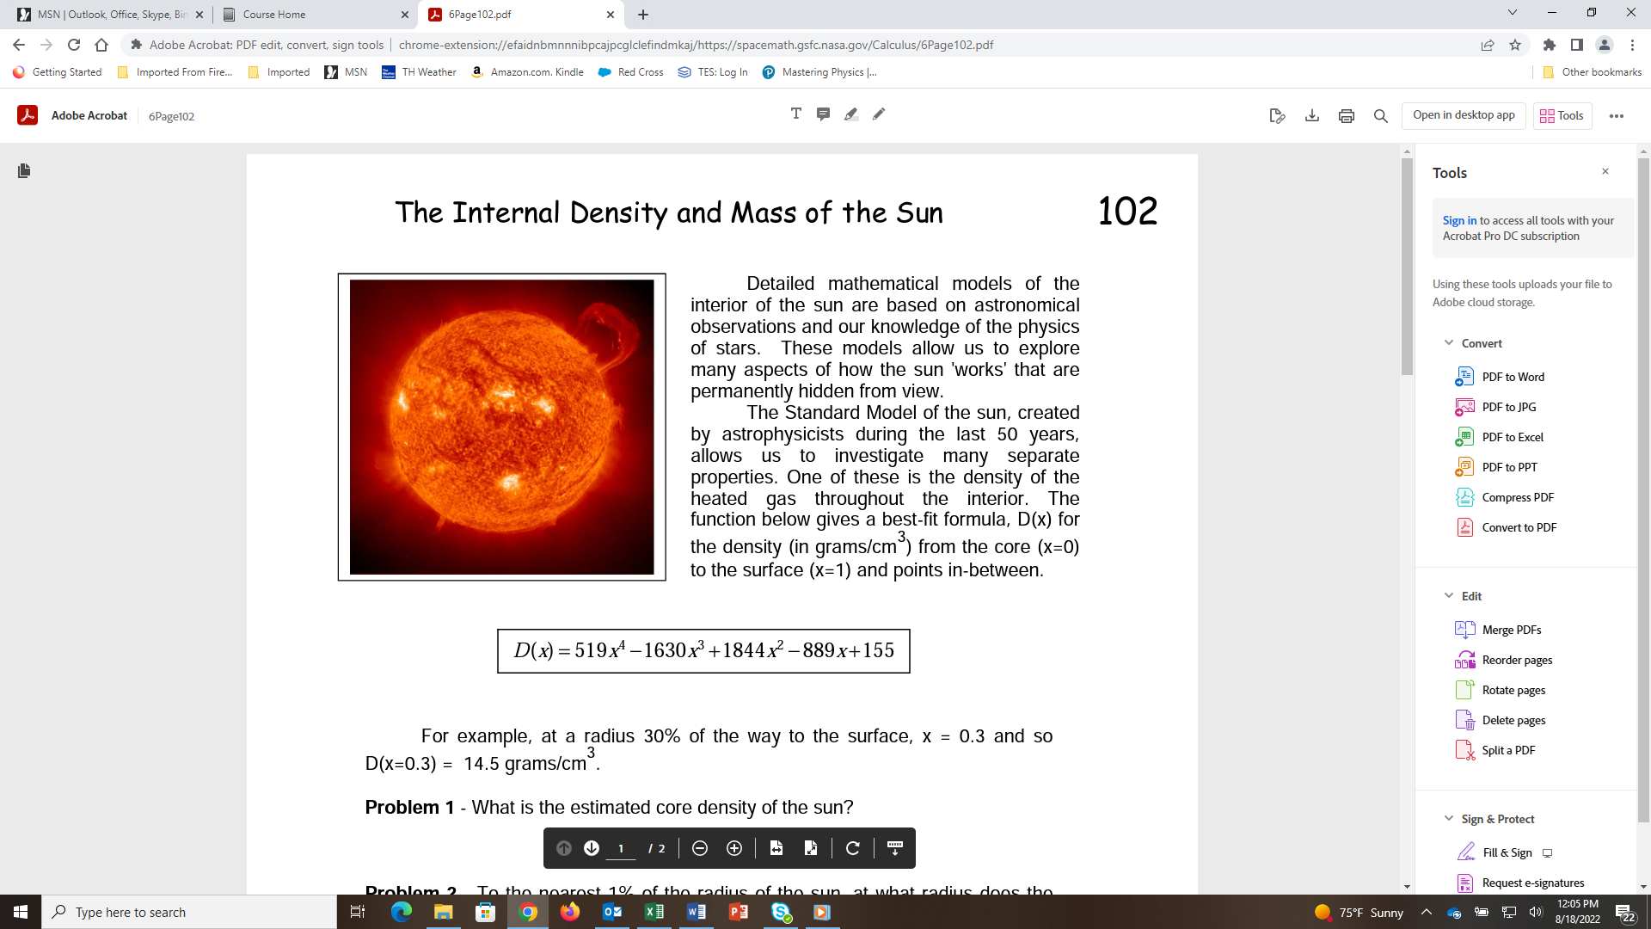

chrome-extension://efaidnbmnnnibpcajpcglclefindmkaj/https://spacemath.gsfc.nasa.gov/Calculus/6Page102.pdf

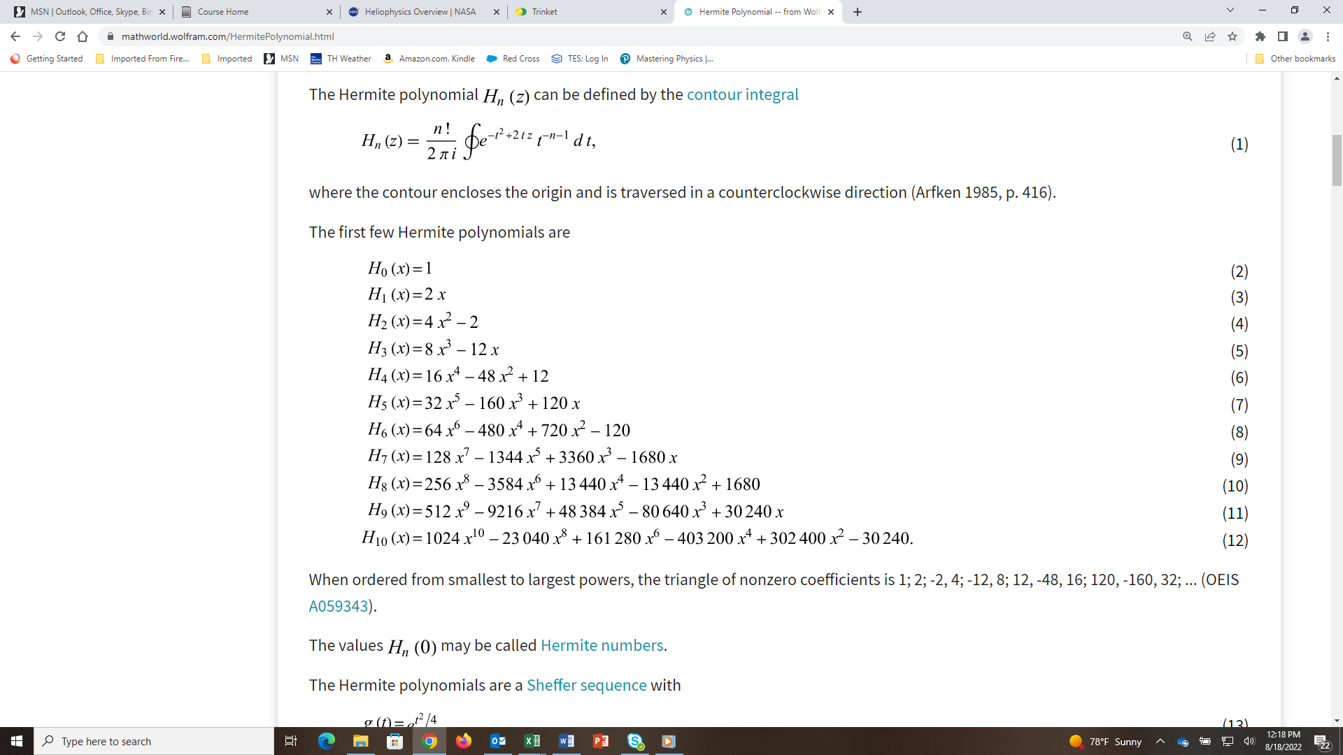

RECURSION RELATION:

$H_{n+1}(x)=2xH_{n}(x)-2nH_{n-1}(x)$

NOTE: Be careful there is also a Probabilits version of these that have extra factors of ½ running around in them.

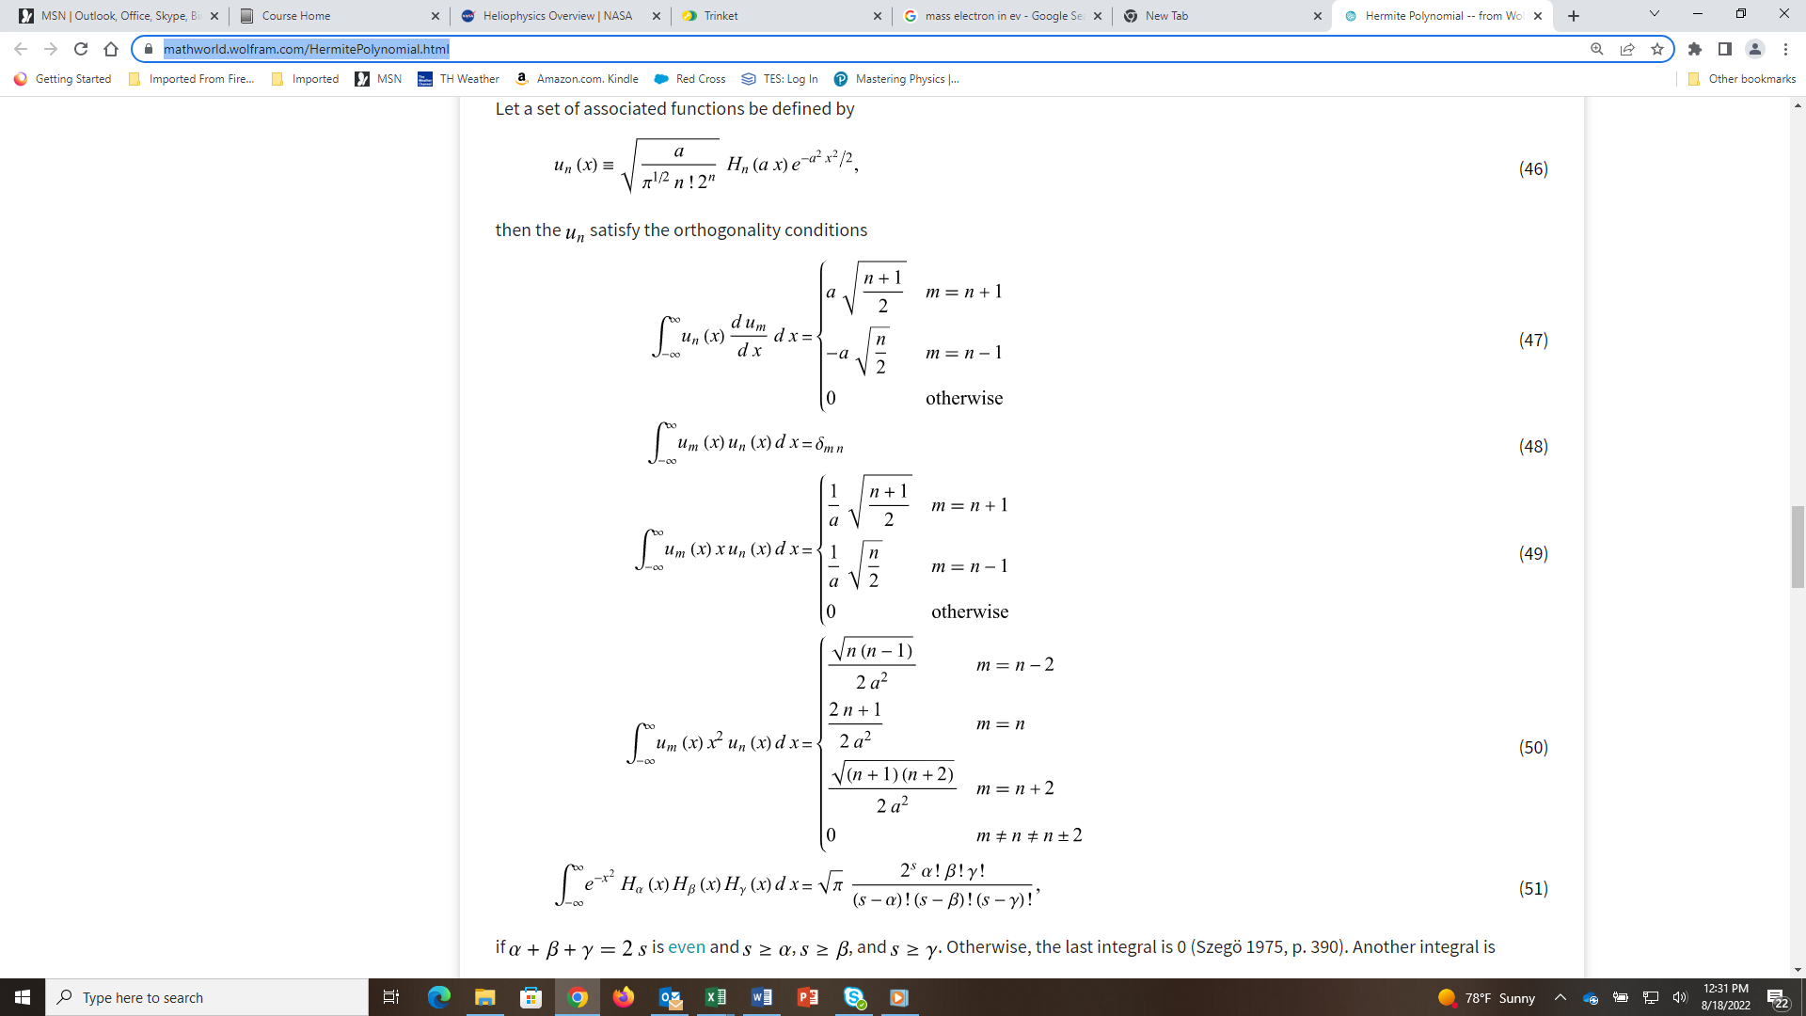

<https://mathworld.wolfram.com/HermitePolynomial.html>